Welcome to Cornerstone!

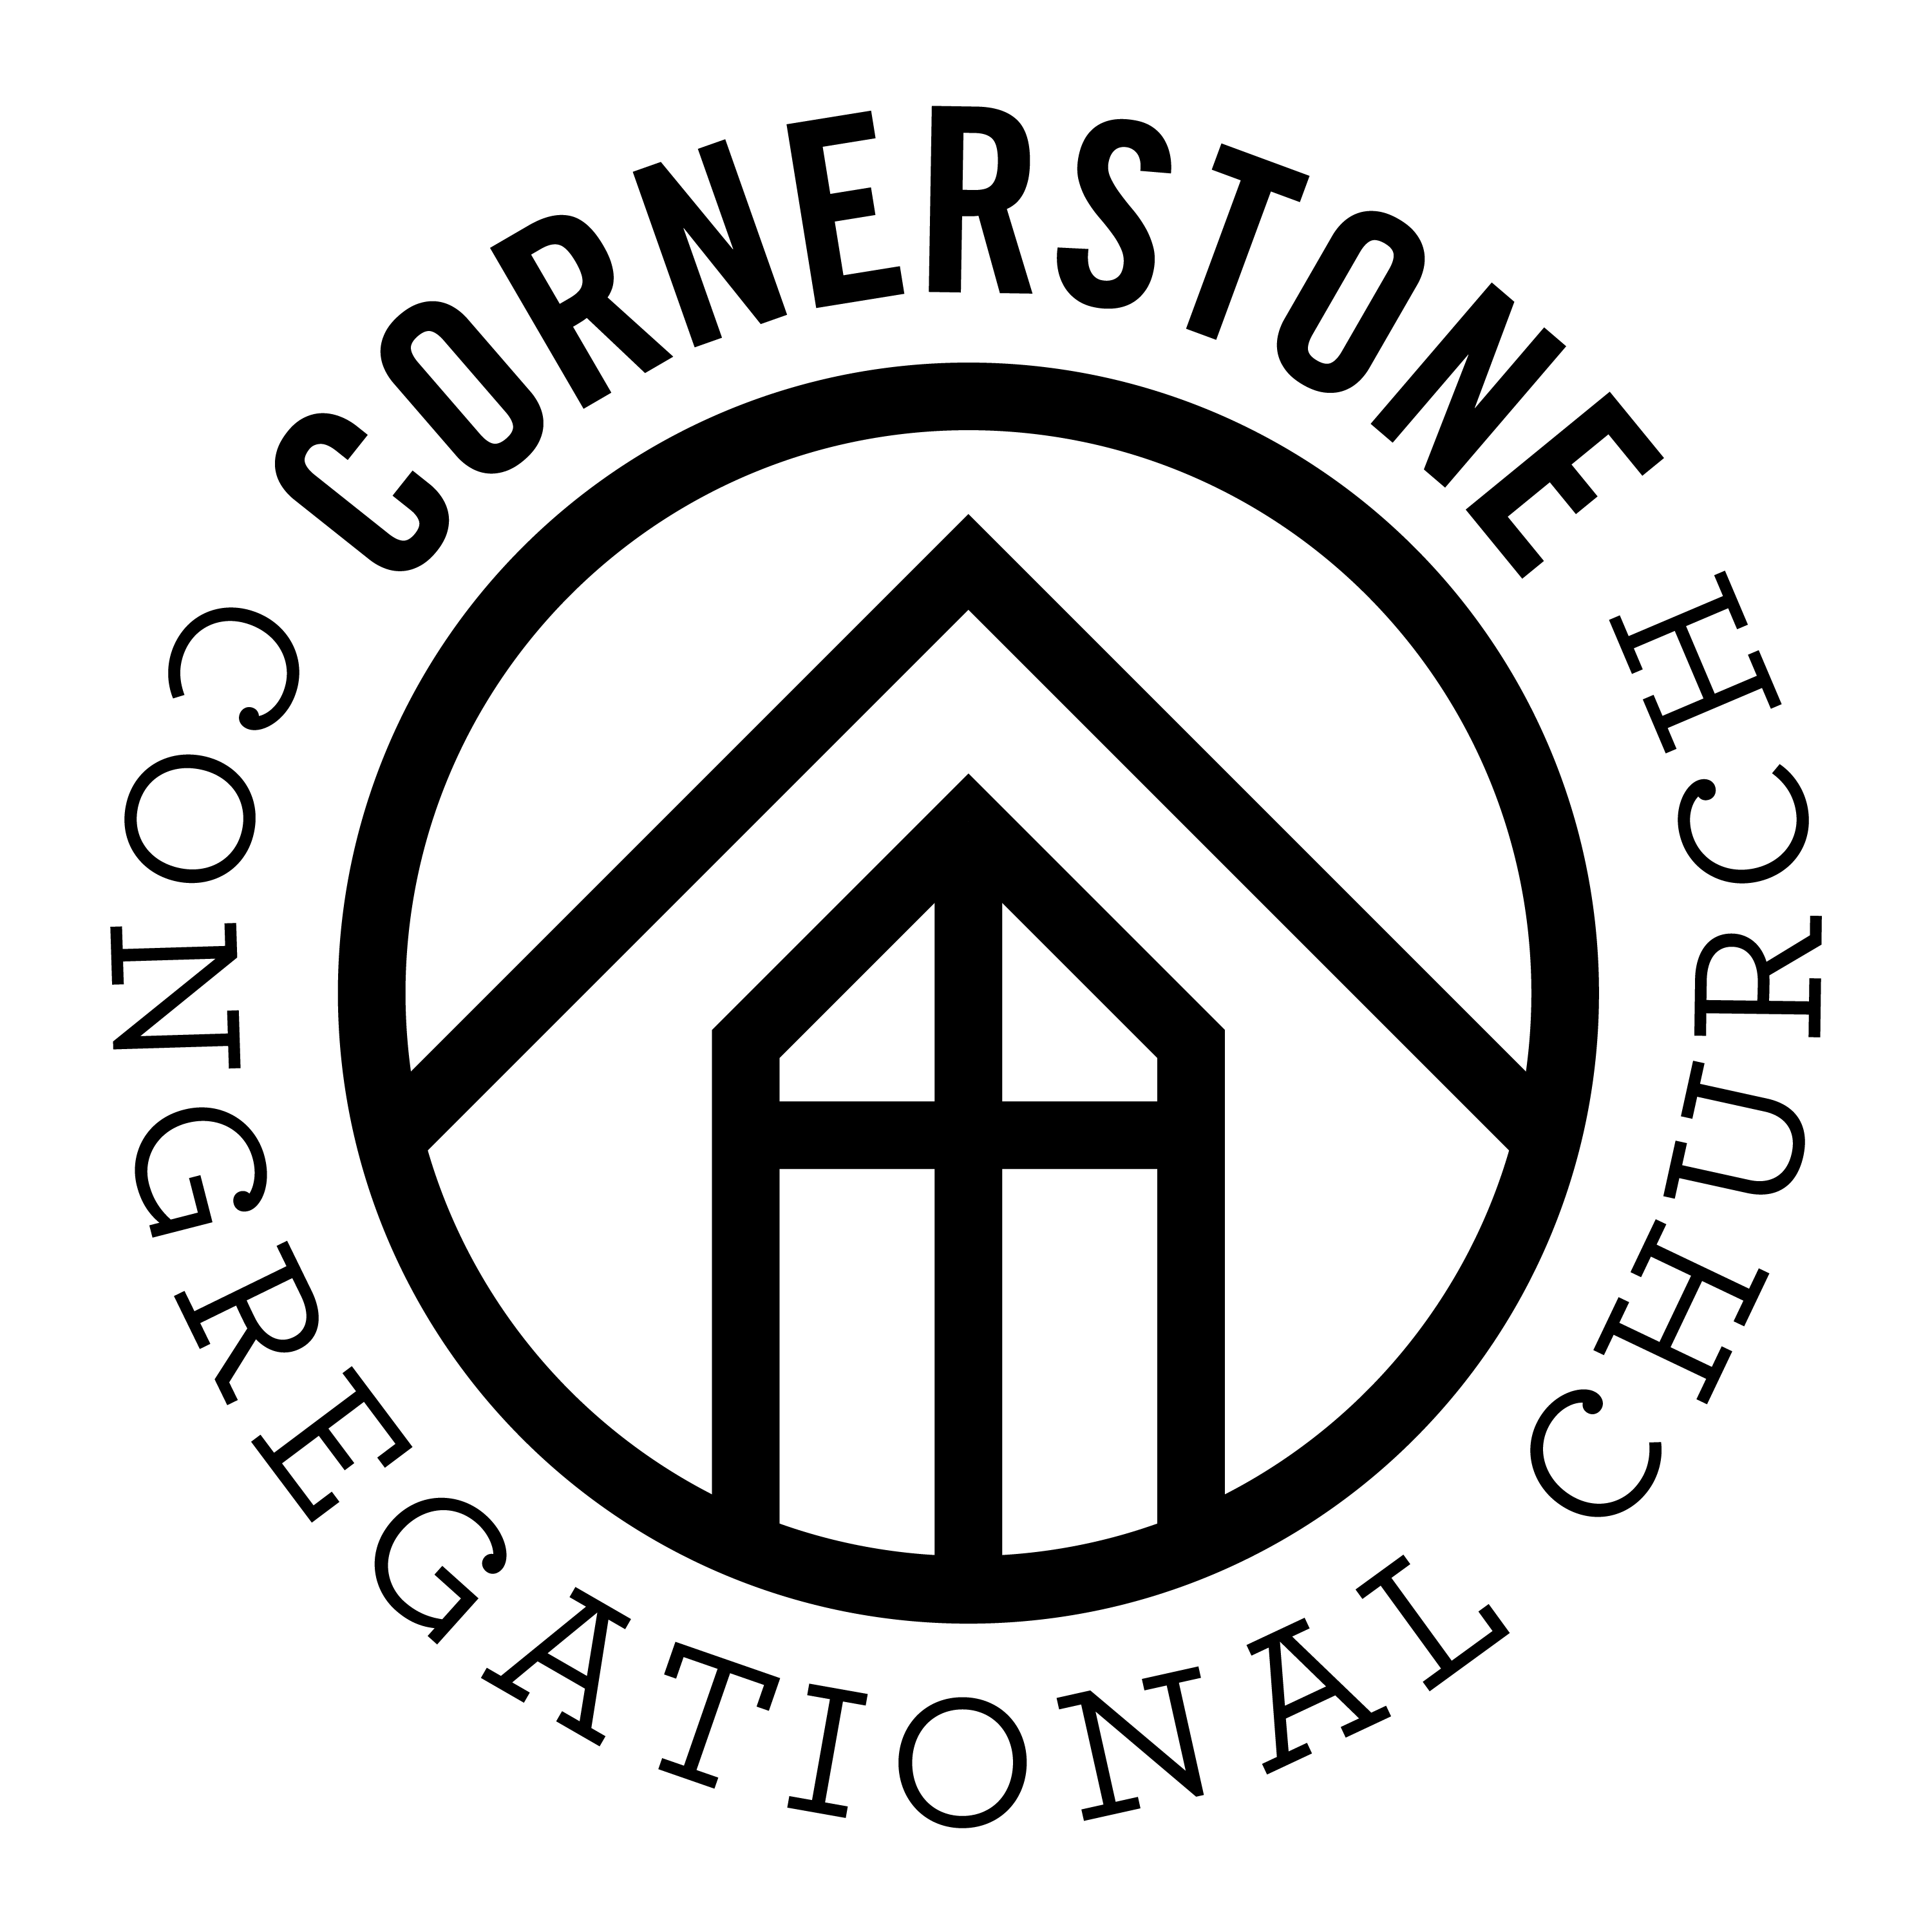

First time Visitors
We are glad you are here! Please take a minute to fill out the white card you found on your seat and turn into our Welcome Center after the service
for a gift.

Cornerstone Kids
Infants – 5th Grade: Infant & Toddler is available downstairs. Cornerstone Kids for K-5th is dismissed from the service.

Bibles
If you don’t have a Bible please take one from the back table and take it home with you.

Our Vision
A gospel-centered church that changes lives through sharing the message of Jesus Christ in word and deed

Our Mission
To make, mature, and multiply followers of Jesus

CornerstoneWestford@gmail.com
978- 692-6360
32 Graniteville Road, Westford, MA 01886
www.cornerstonewestford.com

Social Media Prayer Network
Check us out on Facebook Do you have a prayer request? Cornerstone Congregational Church Fill out the white card, or email
Westford, MA prayer@cornerstonewestford.com

Core Values
Bible - We study, preach, apply and share God’s Word.
2 Timothy 3:16-17

Community – We gather together to worship God and welcome new friends.
Acts 2:42-47

Discipleship – We learn to love and obey Jesus to help others do the same.
Matthew 28:18-20

Love – We receive and share God’s love and grace because Jesus first loved us.
John 13:34-35

Outreach – We serve others and share the gospel.
Jeremiah 29:7; Acts 1:8

Prayer - We invite God to work in our lives, church, and town. Romans 8:26
Foundation Verse
Cast all your anxiety on him because he cares for you.
1 Peter 5:7 (NIV)

Jonathan Romig, Pastor
Saturday, September 17, 2016

Saturday, September 10, 2016

