Cornerstone Spring 2017 Small Groups
Groups start week of May 14th
Registration: April 29, May 6, & 13

Wednesday 7:00pm | Theology 101 | Kevin & Angela Crawford | 69 Tenney Rd. Westford

The word theology is derived from two Greek words: Theos (God) and logos (speech or reason). Therefore, theology in its simplest terms is rational discussion about God. It has been described as "the science of God and his relationship to man and the world" and "the attempt to reduce religious truth to an organized system." Systematic theology is any study that answers the question, "What does the whole Bible teach us today?" If you would like to understand these basics about the Christian faith—such as the doctrines of the Bible, God, Jesus Christ, the Holy Spirit, mankind, the church, salvation, and the future – join this class 6 week class today.
Email: crawfords@cornerstonewestford.com
Angela: 713-203-1138 | Kevin: 832-370-4866

Thursdays 7:00pm | Peacemaking| Joe & Jennie Pelletier | 14 Kenwood St. Chelmsford

Experience the healing power of biblical peacemaking as you learn to apply scriptural principles to conflict in the world around you. Parse the elements of arguments and begin to see that there's not really any difference that can't be overcome with the right perspective. It's practical guidance for resolving all types of conflict and hope for relationships you thought were unsalvageable.

Email: jpelletier@cornerstonewestford.com
Home: 978-688-3626 | Jennie: 978-808-0387 | Joe: 978-808-2790

Friday 7:00pm | The Apostle’s Creed | John & Ann Ralls | 32 Massapoag Way, Dunstable

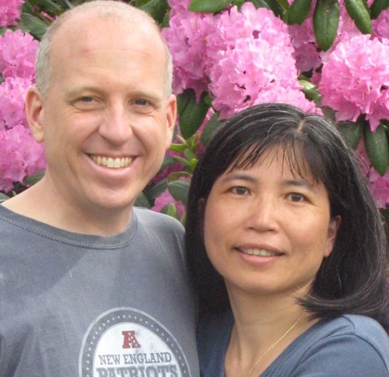
'I believe in God, the Father Almighty...' The Apostles' Creed is recited by Christians throughout the world each Sunday. For many it is a dull routine, and for others, it is spoken with confusion or doubt, rather than with confidence and joy. Do we really need creeds? Increasingly, people do not like the idea of pinning truth down. Others want to stick to the Bible alone, and think that creeds have no place in our worship. But most churches have found it helpful to have a summary of Christian beliefs. Creeds summarize who we are, they teach us what is important and they help us avoid error. In modern business language, they are our 'identity documents'.

Email: jajaralls@gmail.com
Home: 978-649-2647 | John: 978-430-5030 | 978-742-1822

