Cornerstone Fall 2017 Small Groups
Groups start week of January 28th
Registration on-going in Foyer
___________________________________________________________________________________________
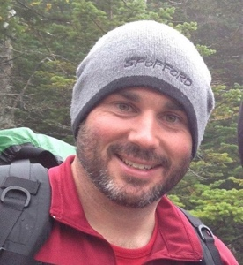

Sundays 10:00am (first meeting on Sunday, January 28th | Andy Bradshaw | 25 Mill Rd, Littleton |

Email: andrewsbradshaw@gmail.com
Phone: Andy 617 519-5314 |

Andy will be leading study based on the book Luke 1-12: The kingdom has come written by Mike McKinley. The seven-week study bringing you face to face with the surprising, powerful, welcoming, joy-bringing Savior of the world.
____________________________________________________________________________________

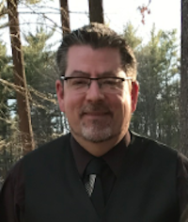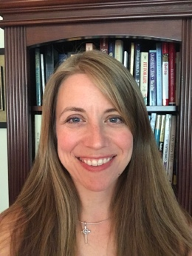

Mondays 6:30pm first meeting on Monday, January 29th) | Jon & Kathy Harwood | 235 Riverbend Dr, Groton |

Email: kathleen.m.harwood@gmail.com
Home: (978) 749-3751| Jon: (978) 494-2941 | Kathy: (978) 494-3916

Jon & Kathy Harwood will be leading an Evangelism Small Group. The session will focus on Evangelism with the goal of helping participants to understand more fully their roles in the Evangelism process, to know and experience how to clearly and comfortably share their faith story with others as they become better prepared to give a reason for the hope that is within them (1 Peter 3:15).
____________________________________________________________________________________________

Thursdays 7:00pm (first meeting on February 1st) | Kevin Crawford | at Cornerstone |

Email: kmcrawford9@gmail.com

Home: 832-644-5895 | Kevin: 832-370-4866Kevin will be leading study based on the book Luke 1-12: The kingdom has come written by Mike McKinley. The seven-week study bringing you face to face with the surprising, powerful, welcoming, joy-bringing Savior of the world.

