Micah 6:8

He has shown you, O mortal, what is good. And what does the Lord require of you? To act justly and to love mercy and to walk humbly with your God. (NIV®)

**Welcome to Cornerstone!**

**First time Visitors**

We are glad you are here! Please take a minute to fill out the white card you found on your seat and turn into our Welcome Center after the service

for a gift.

**Cornerstone Kids**

Infants – 5th Grade: Nursery is available downstairs. Cornerstone Kids for K-5th is dismissed from the service.

**Bibles**

If you don’t have a Bible please take one from the back table and take it home with you.

**Our Vision**

A gospel-centered church that changes lives through sharing the message of Jesus Christ in **word** and **deed**

**Our Mission**

To **make**, **mature**, and **multiply** followers of Jesus

**Social Media Prayer Network**

Check us out on Facebook Do you have a prayer request? **Cornerstone Congregational Church** Fill out the white card, or email

**Westford, MA** **prayer@cornerstonewestford.com**

**CornerstoneWestford@gmail.com**

**978-692-6360**

**32 Graniteville Road, Westford, MA 01886**

**www.cornerstonewestford.com**

**Core Values**

**Bible** - We study, preach, apply and share God’s Word.

**2 Timothy 3:16-17**

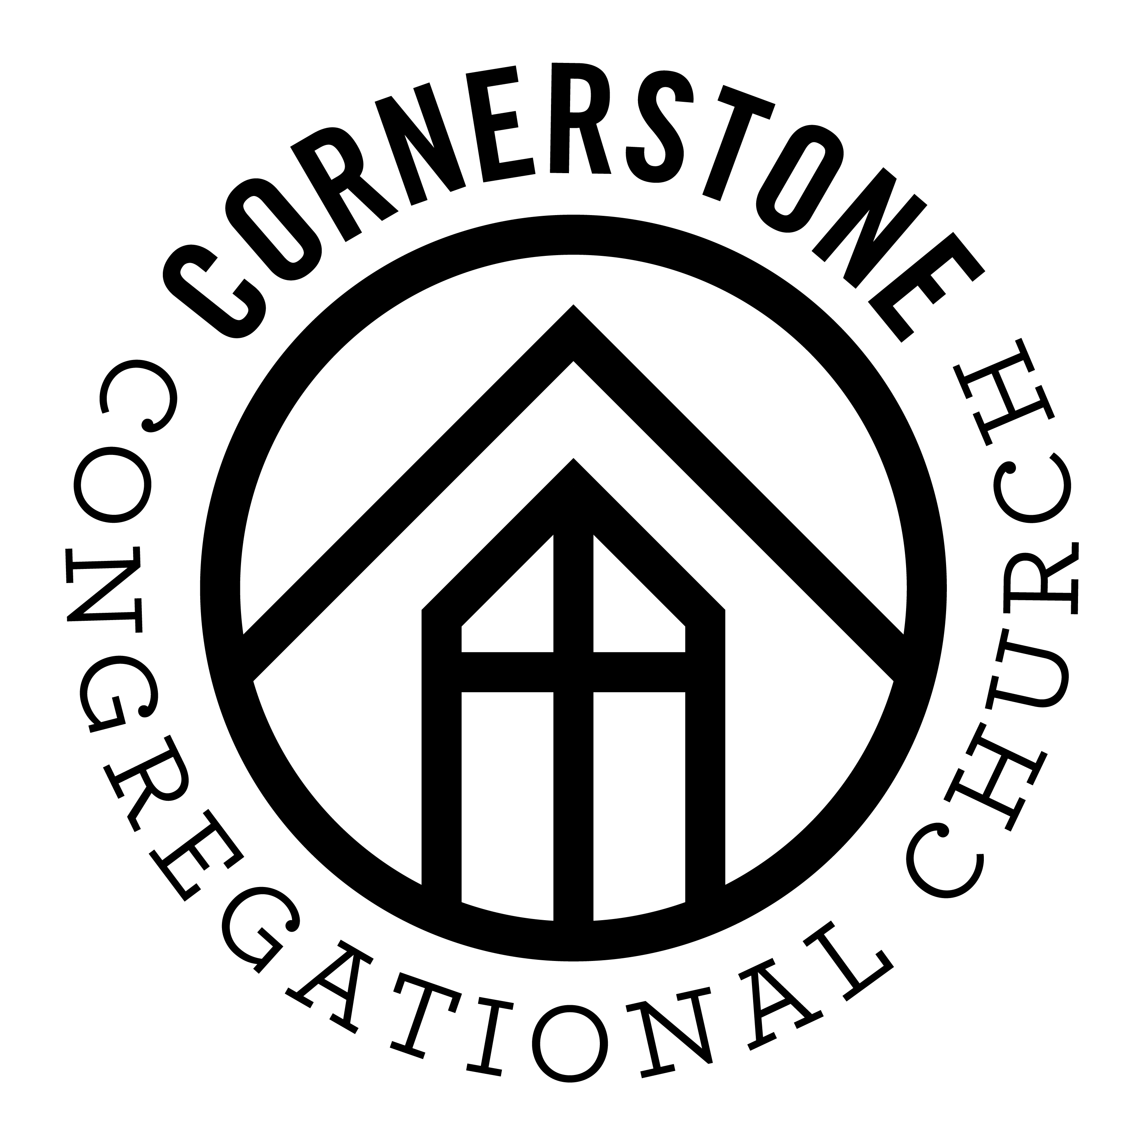**Community –** We gather together to worship God and welcome new friends.

**Acts 2:42-47**

**Discipleship –** We learn to love and obey Jesus to help others do the same.

**Matthew 28:18-20**

**Love –** We receive and share God’s love and grace because Jesus first loved us.

**John 13:34-35**

**Outreach** – We serve others and share the gospel.

**Jeremiah 29:7**; **Acts 1:8**

**Prayer** - We invite God to work in our lives, church, and town. **Romans 8:26**

**Jonathan Romig, Pastor**

**March 2, 2019**

Saturday, September 10, 2016