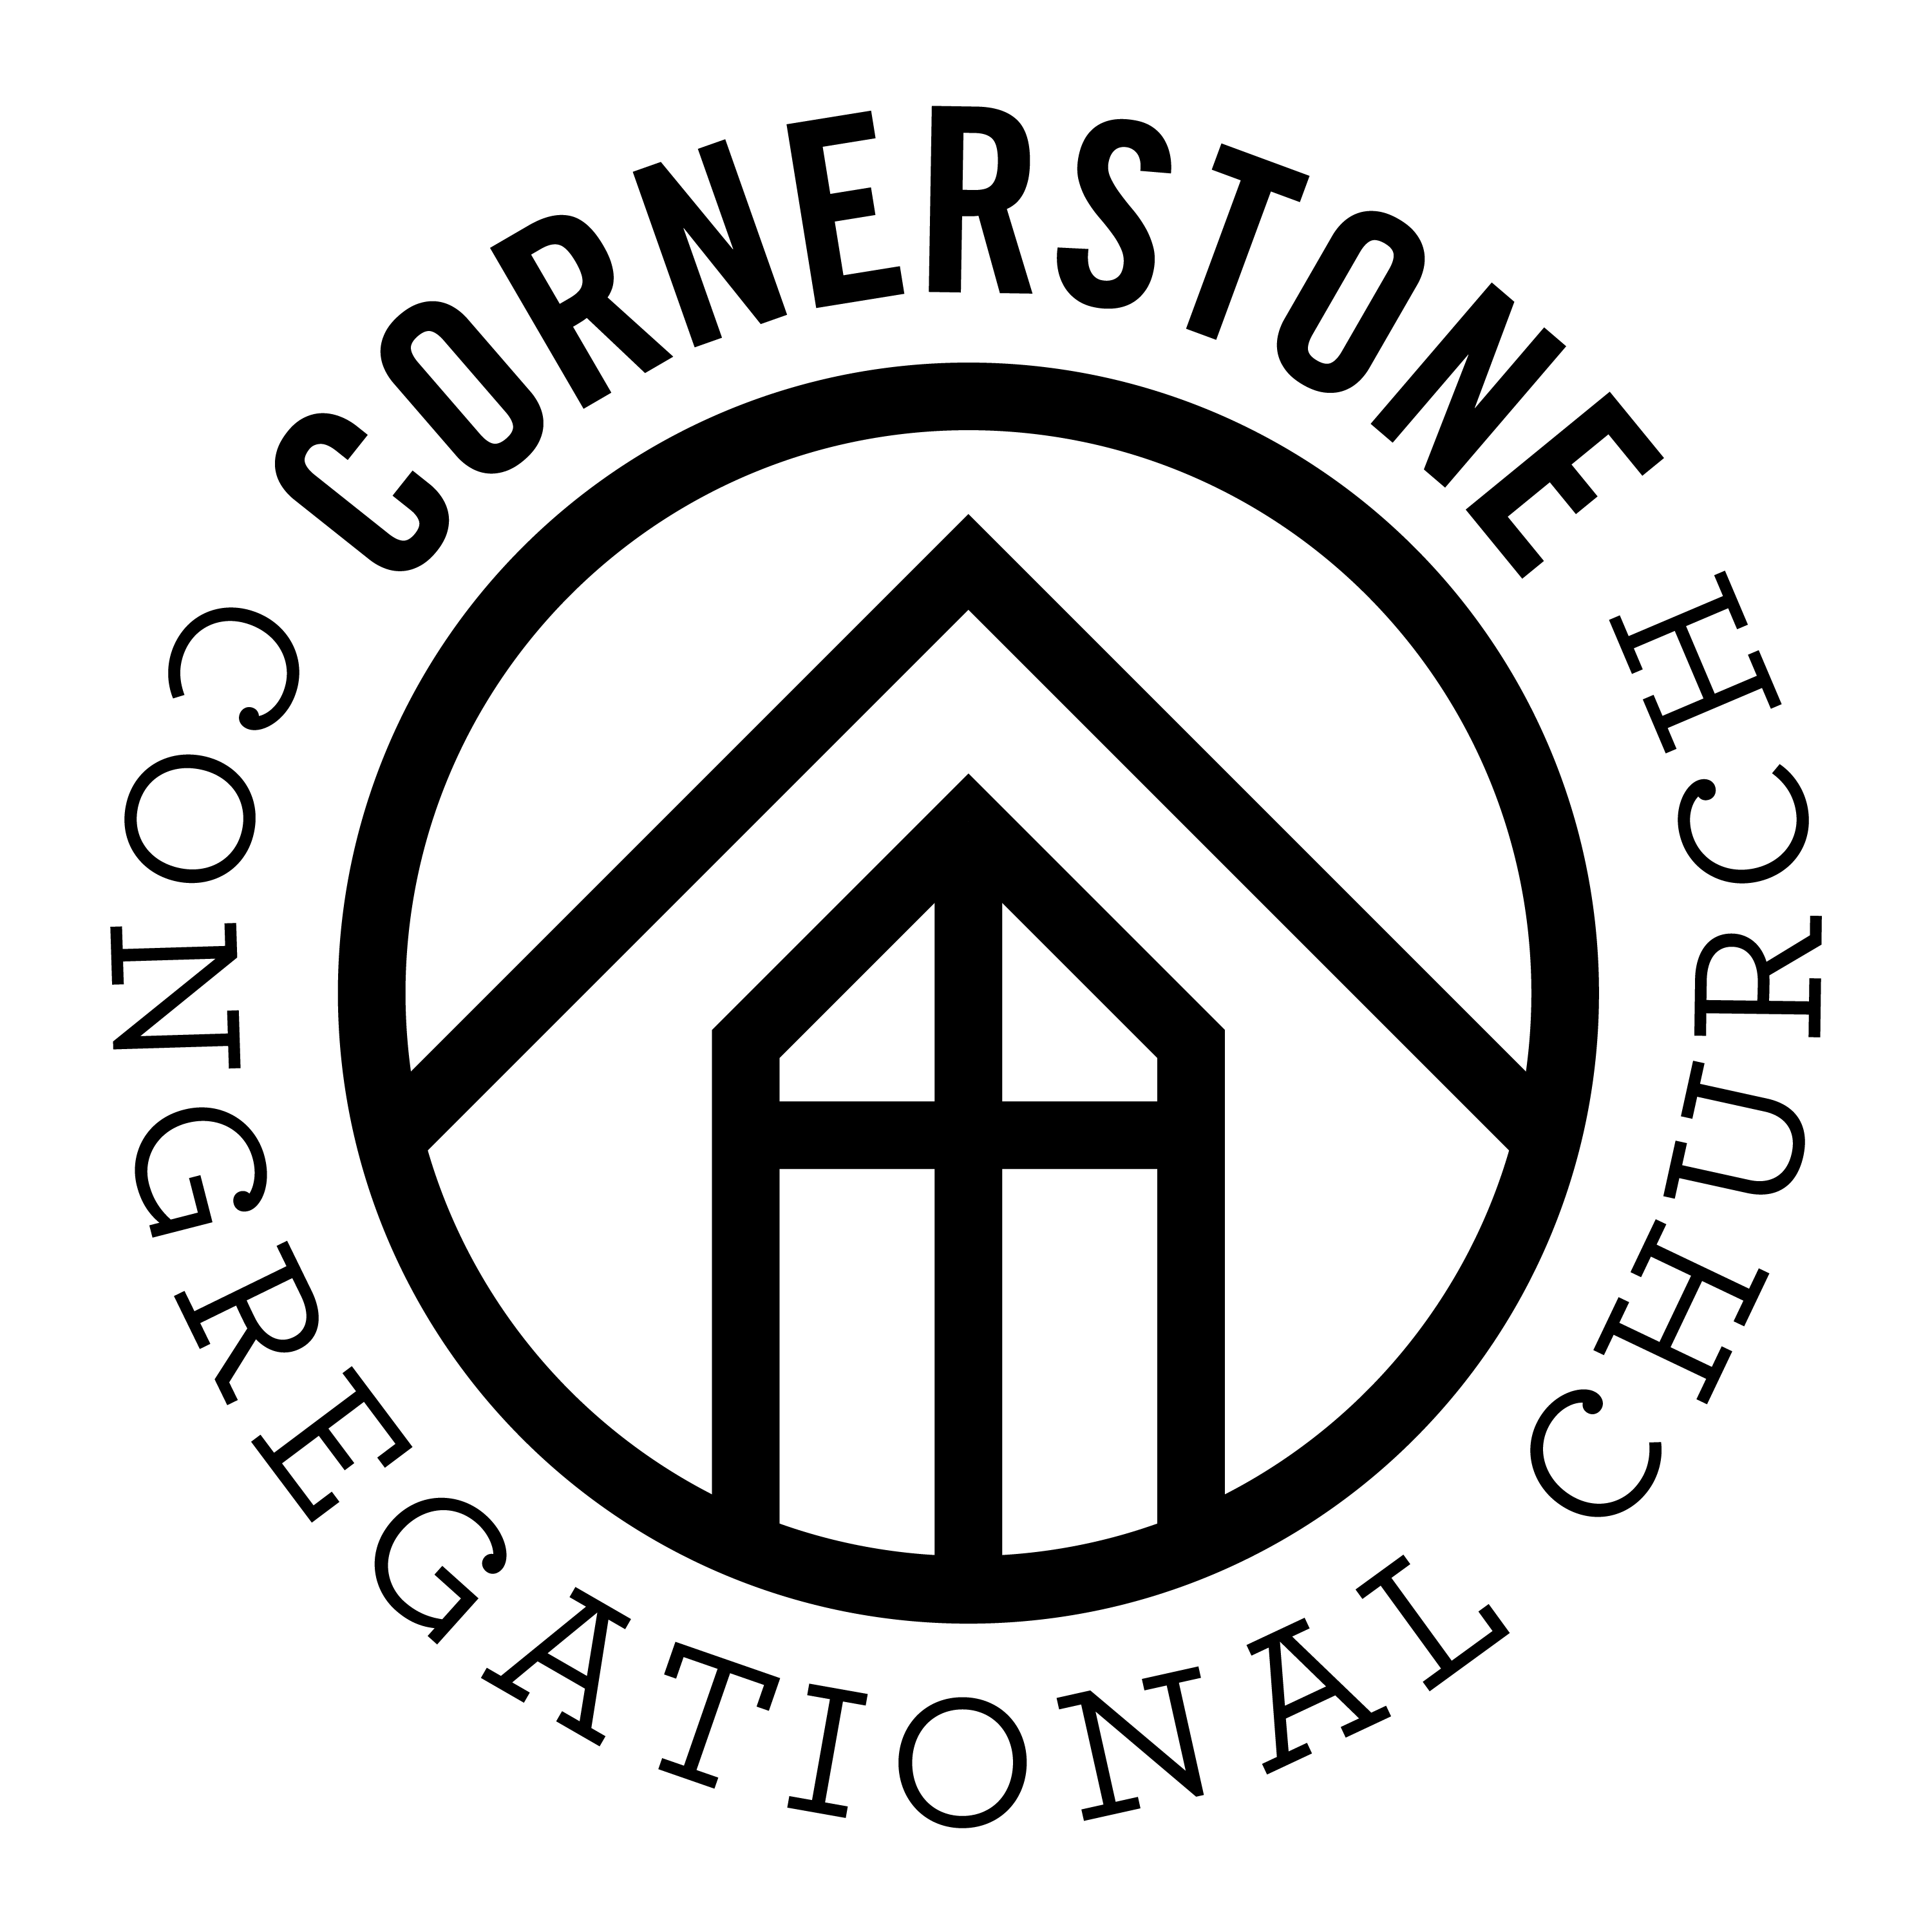
Our Vision
A gospel-centered church that changes
lives through sharing the message
of Jesus Christ in word and deed

Jonathan Romig, Pastor
Saturday, August 13, 2016

CornerstoneWestford@gmail.com
978.692.6360

32 Graniteville Road
Westford, MA 01886
www.cornerstonewestford.com

Foundation Verse Review
Review our memory verses from the past year

He is the one we proclaim, admonishing and teaching everyone with all wisdom, so that we may present everyone fully mature in Christ. Colossians 1:28
Then Jesus came to them and said, “All authority in heaven and on earth has been given to me. Therefore, go and make disciples of all nations, baptizing them in the name of the Father and of the Son and of the Holy Spirit, and teaching them to obey everything I have commanded you. And surely I am with you always, to the very end of the age.” Matthew 28:18-20
“The virgin will conceive and give birth to a son, and they will call him Immanuel” (which means “God with us”)… Matthew 1:23
Jesus replied: “‘Love the Lord your God with all your heart and with all your soul and with all your mind.’ This is the first and greatest commandment. And the second is like it: ‘Love your neighbor as yourself.’ All the Law and the Prophets hang on these two commandments.” Matthew 22:37-40
"Therefore do not let anyone judge you by what you eat or drink, or with regard to a religious festival, a New Moon celebration or a Sabbath day. These are a shadow of the things that were to come; the reality, however, is found in Christ." Colossians 2:16-17
“In the beginning God created the heavens and the earth. Now the earth was formless and empty, darkness was over the surface of the deep, and the Spirit of God was hovering over the waters.”
Genesis 1:1-2
"Abram believed the Lord, and it was credited to him as righteousness." Genesis 15:6

