Cornerstone Winter 2017 Small Groups
Groups start week following January 28th
Registration: January 14th, 21st and 28th

This winter, Cornerstone Small Groups will be following along with the sermon series on Exodus and studying the book Exodus: Liberating Love by Tim Chester. Exodus is the story of a bush on fire that never burns up, an unarmed shepherd facing the most powerful man on earth, a nation walking through a sea, storms, earthquakes and more. But it is supremely the story of the God who reveals himself, triumphs over his enemies, and rescues, guides, rules, forgives and lives with his people—and who in all this points forward to a still greater, more thrilling act of liberation. The groups will meet for 8 weeks.

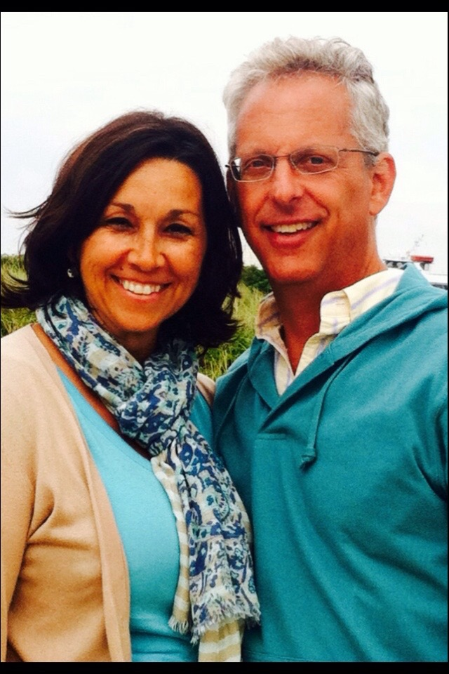
Tuesdays 7:30pm | Chris and Trisha Coughlin & Terry & Sara Iles | 40 Kirsi Circle |Westford

Chris and Trisha have been married for 30 years. They've lived in Westford for almost 15 of those years and have five children. The three oldest children, Kaitlyn (married to Matt), Gregg and Micaela no longer live at home, while Josiah and Jonathan are still at home with Dad, Mom and their friendly golden retriever Cisco. Chris and Trisha look forward to this series and hope you can join them in discovering how God reveals himself in Exodus. Kids welcome.

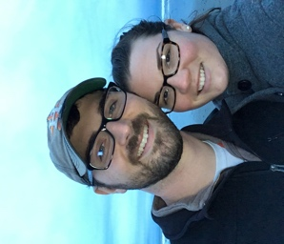
Terry and Sara have been married for 7 years and have a fun daughter named Emma. They are both from Louisiana and moved Boxborough, MA in August. Terry and Sara are excited to study Exodus and to encourage and be encouraged in our small group.

Chris & Terry will be co-leading this small group.

Email: chris.coughlin@cornerstonewestford.com
Home: 978-392-4622 | Chris: 978-501-2520

Thursdays 7:00pm | Kevin & Angela Crawford | 69 Tenney Rd| Westford
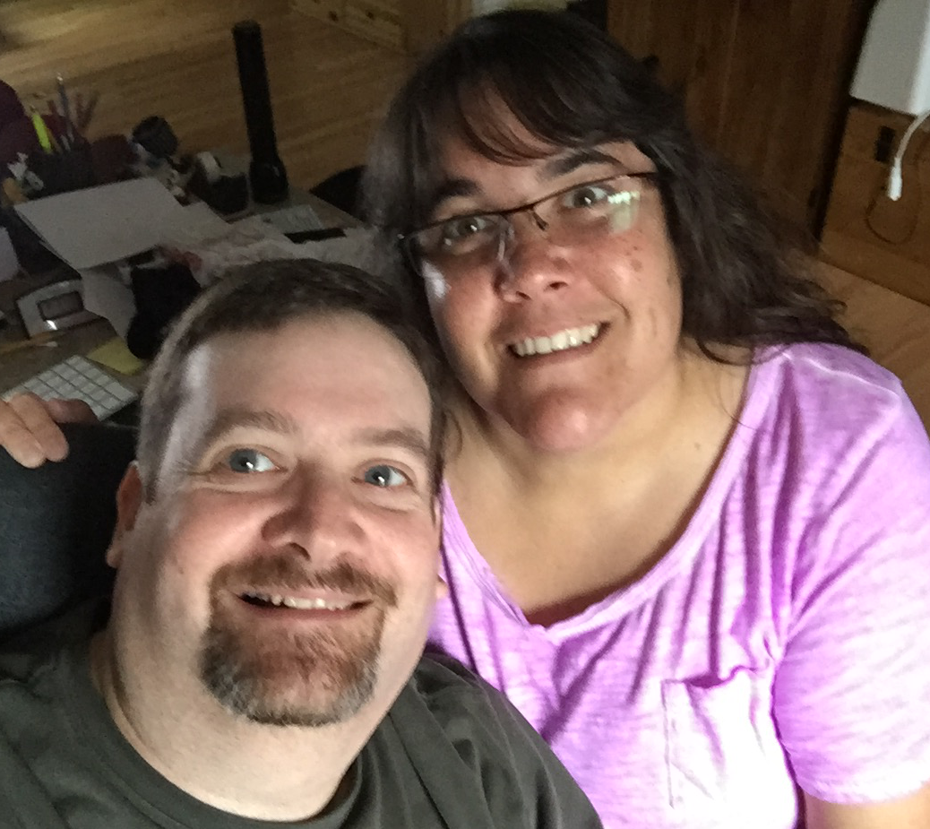
Kevin and Angela moved to Westford in February from the Houston, Texas area. They both grew up as pastor’s kids and have lived all over the country. They have been married 15 years and have 4 kids, Molly, Ruthie, Cammie, and Sawyer. They like to travel, spend a lot of time visiting the kids’ grandparents and being involved in Westford’s activities. Snacks will be provided. Kids are welcome and they have no pets.

Email: crawfords@cornerstonewestford.com
Angela: 713-203-1138 | Kevin: 832-370-4866

Wednesday 7:00pm | Life Explored | 32 Graniteville Rd | Westford
We all want to be happy. Why is lasting happiness so hard to find?
Life Explored is an expose of the little gods that promise us so much happiness, yet deliver so little. As this class explores the Bible story (creation, fall, redemption, new creation), Life Explored shows how our deepest desires for happiness can only be satisfied in one person, Jesus Christ. The best gift God can give us is himself.

Instructor: Pastor Jonathan Romig
Location: Cornerstone Conference Room
Dates: February 1-March 15
Wednesdays 7:00pm – 8:30pm (7 weeks)

Register online through the Roudenbush Community Center.
Cost: $8 (Non-Resident) or $5 (Westford Resident).
Free for those that ask.

