Satan the Adversary
July 22, 2017
Cornerstone –Westford
By Rev. Bernie Michaud

During the last year that I spent in high school till my second year of college, Uncle Sam would send me these little invitations.

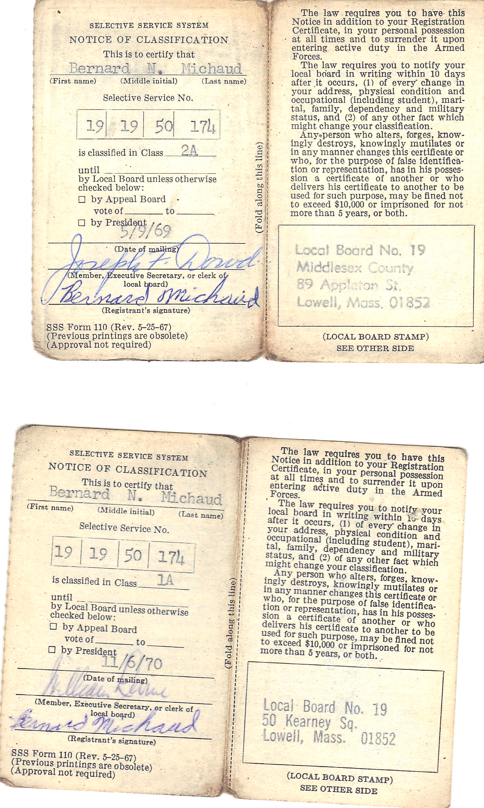
About every two to three months he would offer me an all expenses paid class trip.
Some of my classmates jumped at the idea only to find out that Vietnam was a pretty hot place with lots of humidity.
Most of my close friends were Canadian French descent and we would spend some of our weekends in Montreal.
Montreal was a five hour drive and Saint Catherine St. was the place to be.

So, even though some of my class mates seemed eager to go to Nam, I wanted to know more about it.
I wanted to know:
Where was this place?
What were we going to do there and why?
What did these people do to us?
There were very conflicting answers and I still am not sure what was really going on.
But, if Uncle Sam had not sent me those invitations I still would have no idea where Vietnam is.

In the same way, before I became a Christian, I really didn’t know much about Satan.
Then within a short time I was told that this Jesus that I had decided to follow had an enemy.
His name was Satan and he was out to destroy me.
If you are a believer, he is out to destroy you too.

So what do we know about Satan?

Cornerstone is a Christian church that affirms the orthodox, historic faith taught in the Scriptures. Our beliefs are summarized in the following Articles of Faith, which are affirmed by all our members.
- 6. We believe in the existence of Satan37 and the fallen angels,38 the adversaries of God and His people.39 Equipped Christians40 can successfully resist them through the power of the Holy Spirit.

When Jonathan asked me to preach on Satan, my response was sure; I am in contact with him every day.
The truth is, whether you know it or not, you too are in contact with him as often as I am.
The purpose of this sermon is to make you aware of his schemes so that you are not as likely to fall prey to him.
Satan is definitely out to destroy you and your loved ones.
And if you are a Christian you are a prime target.
Satan wants the honor and praise that we give to God.
The name, “Satan,” means adversary.

Today we are going to try to learn some about this adversary of God but before we start, let’s pray.
Father as we come before you today, we pray that you would help us to understand the battle that we face. We pray that you would help us to see how we are influenced by Satan and how we as believers can learn to resist him. I pray also Lord for your protection for these people before me. Amen.

What is the origin of Satan?
In Genesis 1:31 we find that God had just created the world and had made man and He saw all that He had made and declared that it was good.
But then by Genesis chapter 3 we see Satan in the form of a serpent tempting Eve.
And it is believed that sometime between these two events that there must have been some kind of rebellion in the angelic world where many angles turned against God and became evil.
We find this taught in two places in the New Testament.
- 2 Peter 2:4 says, “For if God did not spare angels when they sinned but sent them to hell, putting them into chains of darkness to be held for judgment.”
- Jude 6 says, “And the angels who did not keep there positions of authority but abandoned their proper dwelling, these he has kept in darkness, bound with everlasting chains for judgment on the great day.”

In the Old Testament we find an account in Isaiah 14:12-15 that most believe describes Satan:
- How you have fallen from heaven, morning star, son of the dawn! You have been cast down to the earth, you who once laid low the nations! You said in your heart, “I will ascend to the heavens; I will raise my throne above the stars of God; I will sit enthroned on the mount of assembly, on the utmost heights of Mount Zaphon. I will ascend above the tops of the clouds; I will make myself like the Most High.” But you are brought down to the realm of the dead, to the depths of the pit. (NIV®)

Satan’s desire was to be above God.
His deepest sin was pride in the form of rebellion.

You may be thinking that this was a really bold move.
Satan wanted his own throne above that of God’s.
But look in Mark 10:35-37
James and John also want to be the greatest.
They want to be on the right and the left of the throne.

Just as Satan tried to deceive Eve in the garden, he also tried to deceive Jesus in the dessert.
In Matthew chapter four we find this account.
Satan, who had success in the garden, would not have success in the dessert.
Jesus came to earth to take back that which the enemy had taken.
- Luke 4:18, "The Spirit of the LORD is upon me, because he has anointed me to proclaim Good News to the poor. He has sent me to proclaim freedom for the prisoners and recovery of sight for the blind, to set the oppressed free, (NIV) (Isaiah 61:1)
Satan offered Jesus the chance to make Himself king of the earth.
All Jesus would have to do is to worship Satan.

Jesus responded, “Get away from me Satan, for it is written worship the Lord your God and serve Him only.
Jesus knew that at that time He had come to serve.
He had come to put Himself under God.
God had a plan for Jesus.
God also has a plan for you.

Today, Satan’s mission is to use all of his power, all of his lies, to try to trick you.
As I said, God has a plan for you but Satan also has a plan.
He would have you to believe that God is holding out on you.
He would have you believe that there is more to life than God is offering you.
This is the same trick that he used on Eve in the garden.
It’s the same trick he used on Jesus in the dessert.
God is calling you to be a servant; Satan wants to offer you a high place.
God loves you but Satan would like you to believe that God just loves Himself.
Can God really be trusted, he asks?
Satan will entice you with sin only to point out your sin to you after.
Satan then uses your shame to try to influence you.
He yells out to you, “You can’t be a Christian, look at your sin!”
He says, “You are a hypocrite; you shouldn’t go to church anymore.”
How many of you have heard this voice?

As I said in the beginning, I was told that this Jesus that I had decided to follow had an enemy.
His name was Satan and he was out to destroy me.
For me now, I see it so clearly.
I understand why he wants to destroy me.
I fully understand why he wants to destroy you.
He hates God and he can’t stand to watch us worship and praise Him.
As the father or lies he will use temptation, doubt, guilt, fear, confusion, sickness, envy, pride, slander or any other means to bring us down.

One thing to remember is that Satan is God enemy.
He is at war with God.
It is God’s place that he wants and not ours.
He just uses us to get to God.
We are just little pawns in the battle.

In the next weeks we will look at how Satan’s work in the garden led to sin which in turned led to death on the earth but as I said, Jesus came to take back that which the enemy had taken.
And so God in His wisdom planned out a way to both save us from our sin and destroy the power of Satan at the same time.
This is crucial for us to understand.
When Jesus died on the cross Satan may have thought that Jesus had been destroyed.
It all looked like it was going well for team Satan.
But when Jesus rose from the grave Satan knew that he was defeated.
Sin would no longer have a grip on man.
Death would no longer have a sting.
In spite of all of this, Satan is still active.
The battles still go on.
He has lost the war but he has not put down his sword.

- In James 4:7 we are told to resist the devil and that by doing so he will flee from us.
We do have the strength to resist him but most of the time we fall prey to him.
We are not the best soldiers as at times we are fighting for the Christian cause,
And then at other times we tend to go over to the enemy’s side.
As children of God we know that He who is in us is greater than he who is in the world.
We may continually fall victim to Satan but God will never let us out of His hand.

And so, what will happen in the end?
In the end, in spite of all of our sin and sins, God will take us home to be with Him.
God has also prepared a place for Satan and his followers.
- Rev. 20:10 says, “And the devil, who deceived them, was thrown into the lake of burning sulfur, where the beast and the false prophet had been thrown. They will be tormented day and night for ever and ever.” (NIV®)

As I said in the beginning, I am in contact with Satan everyday.
You are too.
If you begin to understand this you will be able with the help of God’s Holy Spirit living inside you to resist him.
You will be able tune out his voice when he condemns you.
You will be able to put away the shame and be able to rejoice knowing that God fully loves you!
You will be able to worship God knowing that He gives you His very best.

