Cornerstone Fall 2017 Small Groups
Groups start week of September 17th
Registration: August 26 through September 16th

Discipleship Explored is a journey into the book of Philippians. As they discover Paul's extraordinary letter, participants explore for themselves the meaning of Paul's words: "For me, to live is Christ and to die is gain."

Discipleship Explored is ideal for young Christians but is also great for anyone who wants to grow in their Christian life, being encouraged to stand firm and live for Christ. It is compelling, challenging and inspiring!
___________________________________________________________________________________________
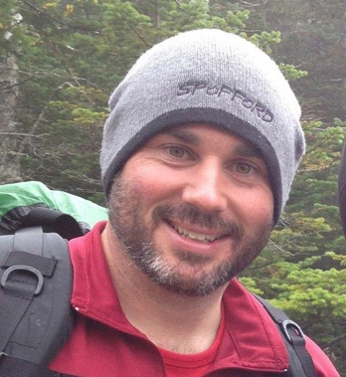
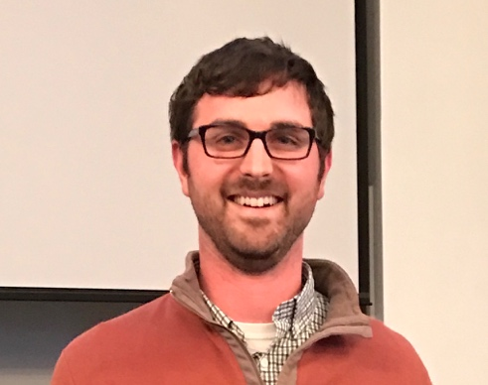

Sundays 6:00pm |Andy Bradshaw & Terry Iles | 25 Mill Rd, Littleton

Email: andrewsbradshaw@gmail.com, terryiles_84@yahoo.com
Phone: Andy 617 519-5314 | Terry: 337-396-7307
____________________________________________________________________________________________

Fridays 7:00pm |Joe & Jennie Pelletier | 14 Kenwood St. Chelmsford

Email: jpelletier@cornerstonewestford.com
Home: 978-688-3626 | Jennie: 978-808-0387 | Joe: 978-808-2790

____________________________________________________________________________________________

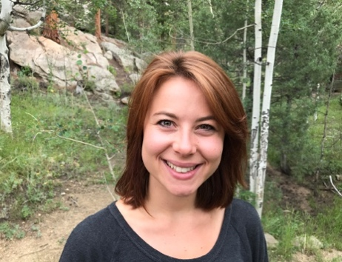

Youth Bible Study
Thursdays 7:00pm to 8:30pm| Monica Romig | at Cornerstone

Email: romig.monica@gmail.com
Phone: 978-905-9338

Come join the Youth Grades 6th through 12th for Bible Study.

