Jonathan Romig, Pastor
Saturday, September 1, 2018

Communion
At Cornerstone, we celebrate the Lord’s Supper, or Communion on the first Saturday of each month. We welcome you to join us as we partake in this remembrance of Jesus' life, death, and resurrection.
What is The Lord’s Supper?
As recorded in 1 Corinthians 11:23-26, Christ commands his followers to observe the Lord’s Supper, remembering Him and proclaiming His covenant work for us.
“For I received from the Lord what I also passed on to you: The Lord Jesus, on the night he was betrayed, took bread, and when he had given thanks, he broke it and said, “This is my body, which is for you; do this in remembrance of me.” In the same way, after supper he took the cup, saying, “This cup is the new covenant in my blood; do this, whenever you drink it, in remembrance of me.” For whenever you eat this bread and drink this cup, you proclaim the Lord’s death until he comes.”
Who may partake?
We welcome all who have put their faith in Jesus Christ to join with us. Jesus is our host at this meal. He prepared it and He invites His people to come. However,
1 Corinthians 11:27-28 cautions us that the Lord’s Supper is serious, and should be done with proper reflection.
“So then, whoever eats the bread or drinks the cup of the Lord in an unworthy manner will be guilty of sinning against the body and blood of the Lord. Everyone ought to examine themselves before they eat of the bread and drink from the cup. For those who eat and drink without discerning the body of Christ eat and drink judgment on themselves.”

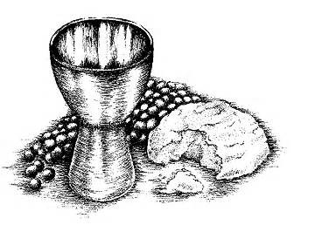

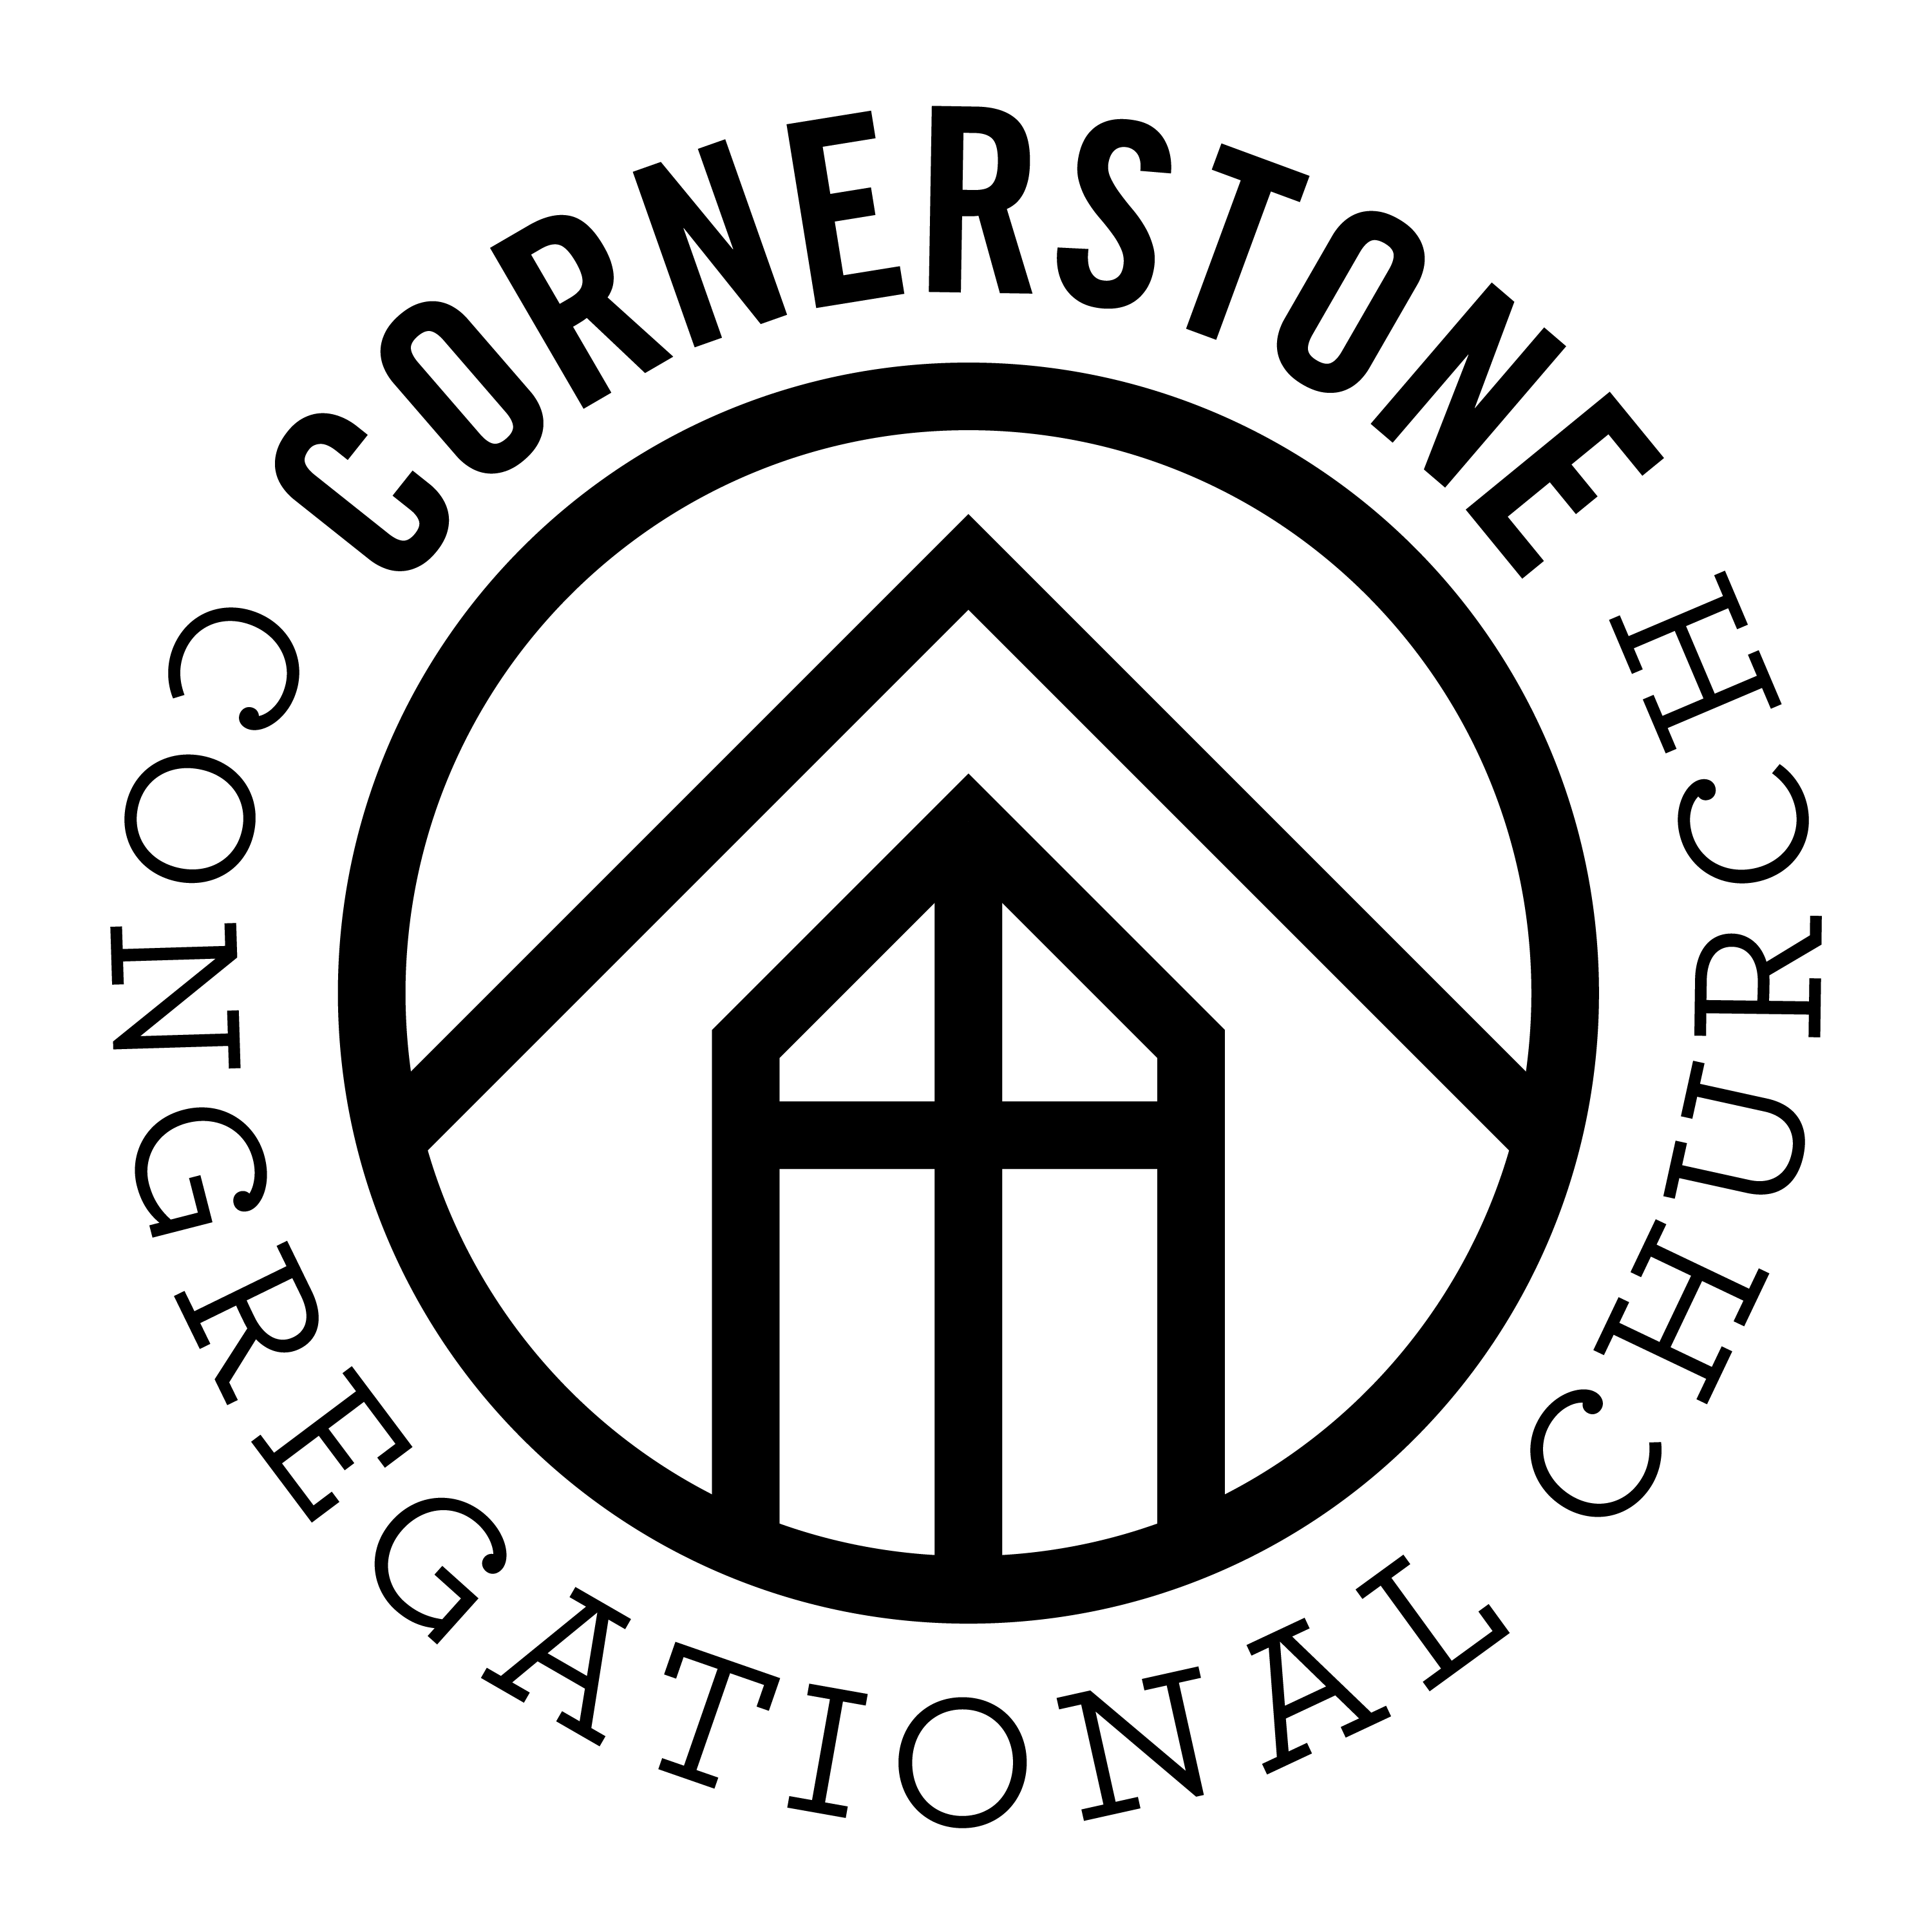

Cornerstone Congregational Church
32 Graniteville Road
Westford, MA 01886
www.CornerstoneWestford.com
978.692.6360

